**All constructs of TQM Implementation**

|  |  |  |
| --- | --- | --- |
| **Construct** | **Related Studies** | **Explanation** |
| Leadership and top  management  commitment | (Prajogo and Sohal 2004) (Prajogo and Sohal 2006) (Dean and Bowen 1994) | Degree of visibility and support that administration presents in implementing a total value natural environment is important to the success of TQM adoption. |
| Customer Focus | (Black and Porter 1996) (Evans and Lindsay 1999) (Hoang, Igel and Laosirihongthong 2006) | To have well persuaded customers is the one of main critical target. Develop and organize powerful customer relationships for the longer period. Know the customers’ current needs and future expectations. |
| Strategic Planning | (Saravanan R. 2007) | The degree to which the organization has a clear vision, operation, long-term design and value policy. |
| Information and  Analysis | (Hackman and Wageman 1974) | The degree to which the organization has a clear vision, operation, long-term design and value policy. |
| Process management | (Teh 2009) | Emphasizing supplementing worth to methods, expanding worth levels, and having program to decrease trashed time and costs in all internal methods. |
| Human Resource  Management | (Wilkinson et al. 1998) | The degree of a wide-ranging management process that is designed and incorporated in the firm’s strategy. |

**Theoretical Framework**

**Leadership**  **Vision & Plan Statement**

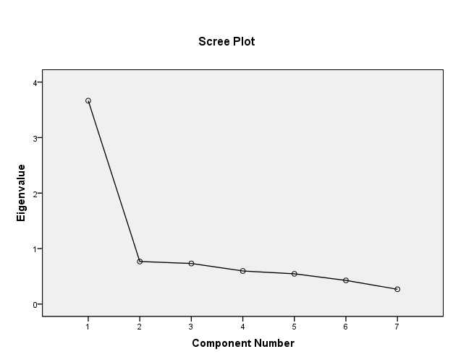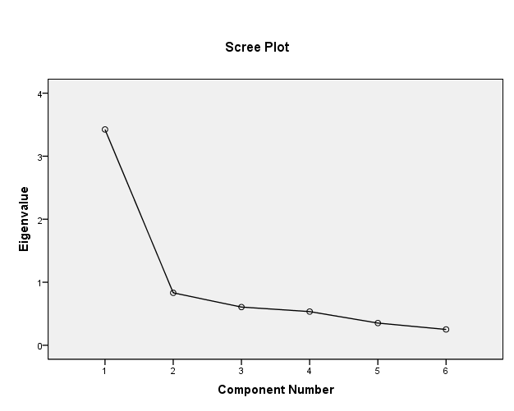

Fig. 2 Fig. 3

**Employee Participation Education & Training** 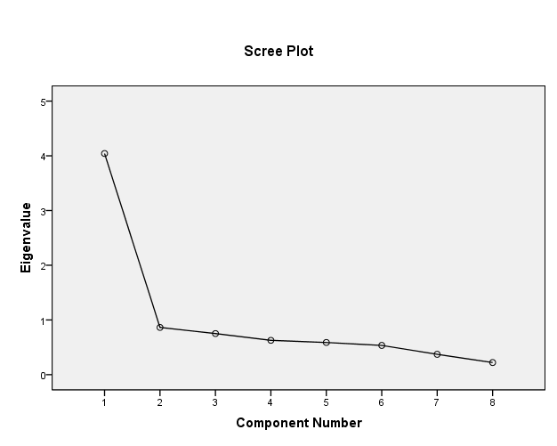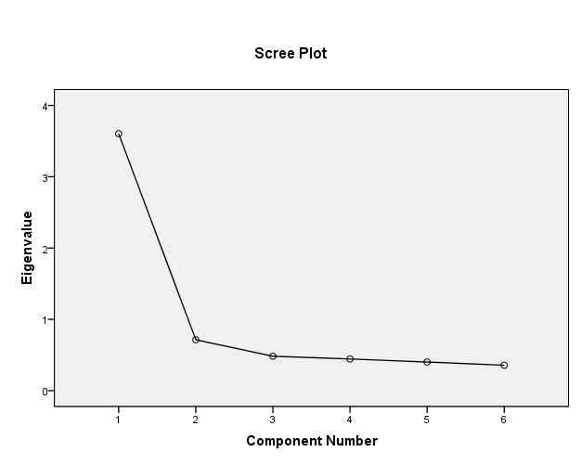

Fig. 4 Fig. 5

**Scatter Plot**

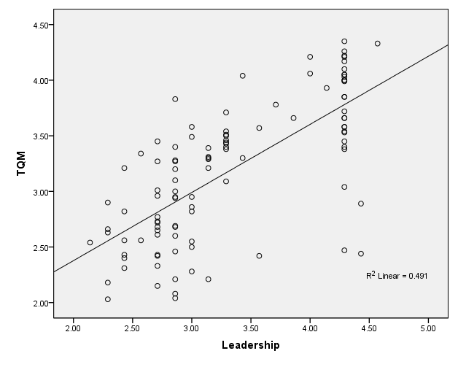 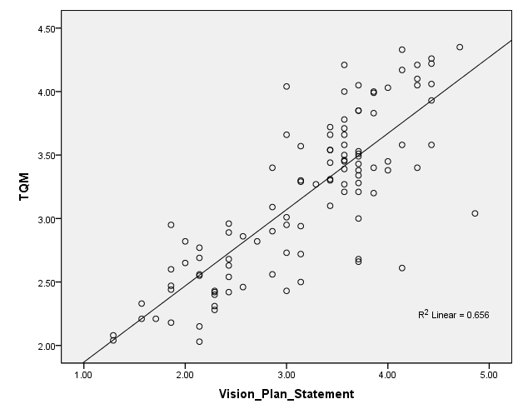

Fig.6 F.g.7

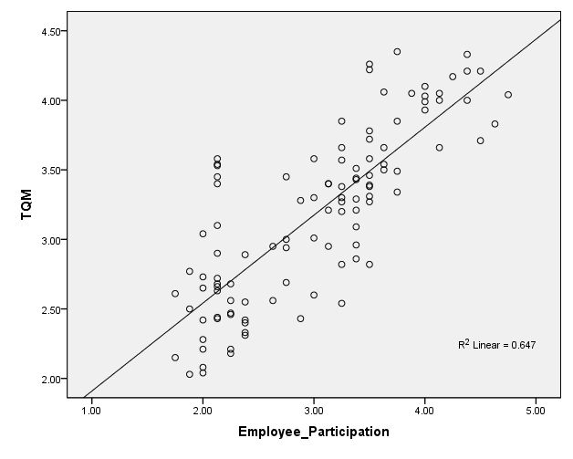 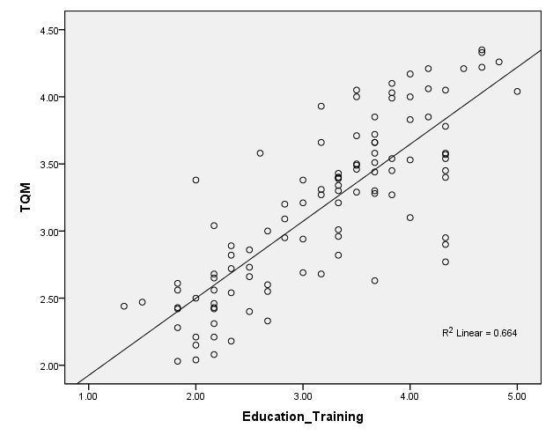

Fig.8. Fig.9

**Reliability** **of All Constructs**

|  |  |  |
| --- | --- | --- |
| **Reliability Statistics** | | |
| Cronbach's Alpha | N of  Items |
| **.769** | **4** |

**Reliability** **of Leadership**

|  |  |  |
| --- | --- | --- |
| **Reliability Statistics** | | |
| Cronbach's Alpha | N of  Items |
| **.847** | **6** |

**Reliability** **of Vision & Plan Statement**

|  |  |
| --- | --- |
| **Reliability Statistics** | |
| Cronbach'Alpha | N of Items |
| **.848** | **6** |

**Reliability** **of Employee Participation**

|  |  |
| --- | --- |
| **Reliability Statistics** | |
| Cronbach's Alpha | N of Items |
| **.848** | **6** |

**Reliability of Education & Training**

|  |  |  |
| --- | --- | --- |
| **Reliability Statistics** | | |
| Cronbach'sAlpha | N of Items |
| **.864** | **6** |

|  |  |  |  |  |  |  |
| --- | --- | --- | --- | --- | --- | --- |
| **Correlations** | | | | | | |
|  | | **Leadership** | **Vision Plan Statement** | **Employee**  **Participation** | **Education Training** | **TQM** |
| **Leadership** | Pearson Correlation | **1** |  |  |  |  |
| N | **106** |  |  |  |  |
| **Vision Plan Statement** | Pearson Correlation | **.491\*\*** | **1** |  |  |  |
| N | **106** | **106** |  |  |  |
| **Employee Participation** | Pearson Correlation | **.431\*\*** | **.528\*\*** | **1** |  |  |
| N | **106** | **106** | **106** |  |  |
| **Education Training** | Pearson Correlation | **.395\*\*** | **.546\*\*** | **.574\*\*** | **1** |  |
| N | **106** | **106** | **106** | **106** |  |
| **TQM** | Pearson Correlation | **.701\*\*** | **.810\*\*** | **.804\*\*** | **.815\*\*** | **1** |
| N | **106** | **106** | **106** | **106** | **106** |
| **. Correlation is significant at the 0.01 level (2-tailed). | | | | | | |

**Regression**

|  |  |  |  |  |  |  |
| --- | --- | --- | --- | --- | --- | --- |
| **Coefficients a** | | | | | | |
| Model | | Un standardized Coefficients | | Standardized Coefficients | T | Sig. |
| B | Std. Error | Beta |
| **1** | (Constant) | **1.152** | **.207** |  | **5.555** | **.000** |
| Leadership | **.613** | **.061** | **.701** | **10.016** | **.000** |
| **2** | (Constant) | **.575** | **.147** |  | **3.919** | **.000** |
| Leadership | **.349** | **.047** | **.399** | **7.472** | **.000** |
| Vision Plan Statement | **.455** | **.040** | **.614** | **11.501** | **.000** |
| **3** | (Constant) | **.245** | **.094** |  | **2.618** | **.010** |
| Leadership | **.260** | **.030** | **.297** | **8.801** | **.000** |
| Vision Plan Statement | **.316** | **.027** | **.426** | **11.877** | **.000** |
| Employee Participation | **.355** | **.027** | **.452** | **13.061** | **.000** |
| **4** | (Constant) | **.107** | **.035** |  | **3.090** | **.003** |
| Leadership | **.235** | **.011** | **.268** | **21.702** | **.000** |
| Vision Plan Statement | **.236** | **.010** | **.318** | **23.143** | **.000** |
| Employee Participation | **.251** | **.011** | **.319** | **23.400** | **.000** |
| Education Training | **.248** | **.010** | **.352** | **25.799** | **.000** |
| a. Dependent Variable: TQM | | | | | | |